1. INTRODUCTION

1.1. Overview of eXe (e-learning XHTML editor)
The aim of this phase of the project is to implement a new web editing application designed specifically to meet the needs of the education community and able to be used with any learning management system(LMS). The software aims to:
- provide a simple web page content editing tool to teachers
- meet global system interoperability standards currently evolving (IMS-LD, SCORM) ensuring content developed with the editor is not LMS dependent
eXe is a dedicated tool for publishing web content. It does not attempt to replicate the features or functions provided by learning management systems. Therefore, eXe will not deal with functions like student management, authentication, or assessment tools.
Phase 1 incorporates the following facilities :
- Administration Module (Properties tab)
- Content Structure and Sequencing Module
- Learning Design template Module
  - Instructional Devices sub-module
  - Container sub-module
- Authoring Module
- Translation and Customisation Module
- Publishing and Packaging Module
[Detailed inclusions are listed later in this document]

1.2. Purpose of this Document
This document is to serve as the Draft Test Approach for the eXe e-learning XHTML editor Project
Preparation for this test consists of three major stages:-
- The Test Approach sets the scope of system testing, the overall strategy to be adopted, the activities to be completed, the general resources required and the methods and processes to be used to test the release. It also details the activities, dependencies and effort required to conduct the System Test.
- Test Planning details the activities, dependencies and effort required to conduct the System Test.
- Test Conditions/Cases documents the tests to be applied, the data to be processed, the automated testing coverage and the expected results.

Test Approach
As our development approach is to release frequently and often our testing approach must mirror this. We are currently releasing on the 10th of each month. Releases will typically include additional features as well as issue and bug resolution from previous releases.

Testing is carried out on the following:
- starting eXe – Firefox is found via registry e.g. Firefox binary, firefox path in exe.conf
- Platforms – ensure release runs on Windows XP, MacOS and Fedora3 Linux
- iDevice editing – idevices perform as designed
- Package properties tab performs as designed
- files can be saved and loaded in all platforms
- export facility works as designed
- CSS styles can be changed, exported and loaded
- runs in different environments

1.3. Formal Reviewing
There will be several formal review points before and during system test. This is a vital element in achieving a quality product.
1.3.1. Formal Review Points
1. Design Documentation
2. Testing Approach
3. Unit Test Plans
4. Unit Test Conditions & Results
5. System Test Conditions
6. System Test Progress
7. Post System Test Review

1.4. Objectives of System Test
At a high level, this System Test intends to prove that :-
- The functionality, delivered by the development team, is as specified by the Design Specification and User Requirements.
- The software is of high quality; the software will support the intended function and achieves the standards required by the TEC and User community for the development of new systems.
- The software delivered, interfaces correctly with existing IMS and SCORM compliant systems.
[Detailed objectives are listed later in this document.]

1.4.1. Software Quality Assurance involvement
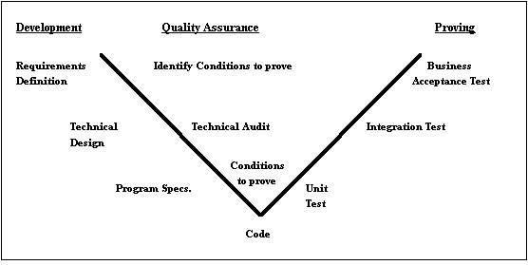
The above V Model shows the optimum testing process, where test preparation commences as soon as the Requirements Catalogue is produced. System Test planning commenced at an early stage, and for this reason, the System test will benefit from Quality initiatives throughout the project lifecycle.
The responsibility for testing between the Project & Software Qualtiy Assurance (S.Q.A.) is as follows:
- Unit Test is the responsibility of the Development Team
- System Testing is the responsibility of Development Team
- User Acceptance Testing is the Responsibility of the User Group
- Technology Compliance Testing is the responsibility of the development Team

2. SCOPE AND OBJECTIVES

2.1. Scope of Test Approach - System Functions

2.1.1. INCLUSIONS
The contents of this release are as follows :-
Phase 1 Deliverables (Production Release April 06)
- issues and bugs reported through Mantiss are updated indicating current status
- application installs have been tested on all plaforms
- all iDevices meet iDevice learning design criteria outlined in iDevice submissions
- iDevice interface has consistent graphic and informative features (tips, layout, language, functionality)
- meta data collection (Properties tab)
- Exporting content packages
- Different system environments (e.g. no network connections, collaborative authoring)

2.1.2. EXCLUSIONS
When the scope of each Phase has been agreed and signed off, no further inclusions will be considered for inclusion in this release, except: where the changes/inclusions will not require significant effort on behalf of the test team (i.e. requiring extra preparation - new test conditions etc.) and will not adversely affect the test schedule.
[See Section 9.1.]
2.1.3. SPECIFIC EXCLUSIONS
- ???
Reference & Source Documentation:
- ???

2.2. Testing Process
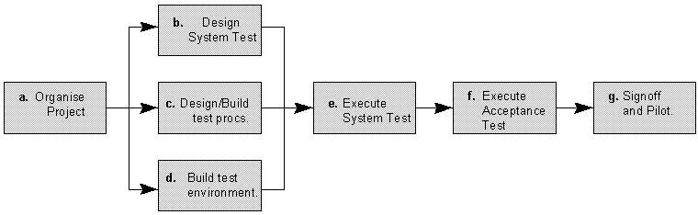
The diagram above outlines the Test Process approach that will be followed.
a. | Organise Project involves creating a System Test Plan, Schedule & Test Approach, and requesting/assigning resources.
b. | Design/Build System Test involves identifying Test Cycles, Test Cases, Entrance & Exit Criteria, Expected Results, etc. In general, test conditions/expected results will be identified by the Test Team in conjunction with the Project Business Analyst or Business Expert. The Test Team will then identify Test Cases and the Data required. The Test conditions are derived from the Business Design and the Transaction Requirements Documents
c. | Design/Build Test Procedures includes setting up procedures such as Error Management systems and Status reporting, and setting up the data tables for the Automated Testing Tool.
d. | Build Test Environment includes requesting/building hardware, software and data set-ups.
e. | Execute Project Integration Test - See Section 3 - Test Phases & Cycles
f. | Execute Operations Acceptance Test - See Section 3 - Test Phases & Cycles
g. | Signoff - Signoff happens when all pre-defined exit criteria have been achieved. See Section 2.4.
2.2.1. Exclusions
If design/functional issues arise they should be resolved by the development team.

2.3. Testing Scope
In keeping with the Open source philosophy of the project, all system test plans and conditions will be developed from the eXe project Road Map and User Group requirements.

2.3.1. Functional Testing
The objective of this test is to ensure that each element of the application meets the functional requirements as outlined by the development team road map and the user group.
Validation Testing – this includes testing of the new Front end fields and screens. Windows, Linux and MacOS GUI Standards; valid, invalid and limit data input; screen & field look and appearance, and overall consistency with the rest of the application.
Specific Functional testing - these are low-level tests which aim to test the individual processes and data flows.

2.3.2. Integration Testing
This test proves that all areas of the system interface with each other correctly and that there are no gaps in the data flow. Final Integration Testing proves that the system works as an integrated unit when all the fixes are complete.

2.3.3. User Acceptance Test
This test, which is planned and executed by the Business Representative(s), ensures that the system operates in the manner expected, and any supporting material such as procedures, forms etc. are accurate and suitable for the purpose intended. It is high level testing, ensuring that there are no gaps in functionality.

2.3.4. Performance Testing
These tests ensure that the system provides acceptable response times (which should not exceed 4 seconds).

2.3.5. Regression Testing
A Regression test will be performed after the release of each Phase to ensure that -
- There is no impact on previously released software, and
- to ensure that there is an increase in the functionality and stability of the software.
The regression testing will be automated using the automated testing tool.

2.3.6. Bash & Multi-User Testing
Multi-user testing will attempt to prove that it is possible for an acceptable number of users to work with the system at the same time. The object of Bash testing is an ad-hoc attempt to break the system.

2.3.7. Technical Testing
Technical Testing will be the responsibility of the Development Team.

2.3.8. Operations Acceptance Testing (OAT)
This will be conducted by the Development Team.

3. TEST PHASES AND CYCLES
There will be two main stages of testing for the new application during System Test :-
- System Testing
- Operations Acceptance Testing

3.1. System Testing Cycles
The main thrust of the approach is to intensively test the front end in the first two releases, thus raising approximately 80% of errors in this period. With the majority of these errors fixed, standard and/or frequently used actions will be tested to prove individual elements and total system processing in Release v0.3. Regression testing of outstanding errors will be performed on an ongoing basis.
When all errors (which potentially impact overall processing) are fixed, an additional set of test cases are processed in Release v0.4 to ensure the system works in an integrated manner. It is intended that Release v0.4 be the final proving of the system as a single application. There should be no A or B class errors outstanding prior to the start of Release v0.4 testing.
Test Cases by Release version:
Testing by Phase
 | Acceptance 1
Release v0.1 | Functional 1
 | User Acceptance
 | Acceptance 2
Release v0.2 | Functional 2
 | Regression 1
 | Acceptance 3
 | Functional 3
Release v0.3 | Performance 1
 | Bash & Multi-User Testing
 | Regression 1
 | Regression 2
 | Integration 1
 | Technical 1
Release v0.4 | Regression 1
 | Regression 2
 | Regression 3
 | Installation Test
Contingency | Per Bug Fix Test Only
3.1.2. Automated Testing
Automated testing tools will be used in the test environment for functional and regression testing. The main focus of the automated testing will be the regression testing of the previously delivered functionality - i.e. when development version 0.2 of the software is delivered the majority of the regression testing of the functionality delivered in development version 0.1 will be automated. It is estimated that the full benefit of the automated testing will only occur when the tests have been executed three or more times.

3.3. Formal Reviewing
There will be several formal review points before and during system test, including the review of this document. This is a vital element in achieving a quality product.
3.3.1. Formal Review Points
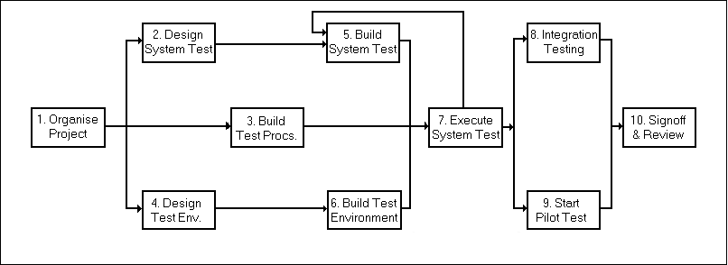
1. Design Documentation - Requirements Specification & Functional Specification
2. System Test Plan
3. Unit Test Plans & Test Conditions
4. Unit Test Results
5. System Test Conditions
6. System Test Progress/Results
7. Post System Test Review
8. Integration Test Results
9. Pilot Implementation Review
10. Project Review
The diagram above outlines the Test Approach. Boxes 1 - 6 show the major review stages prior to Test execution. Boxes 7 - 10 show the phases planned for & after test execution.
3.3.2. Progress/Results Monitoring
- Acceptance Test 1 Results
- Test Results - Release v0.1
- Test Results - Release v0.2
- Test Results - Release v0.3
- Performance Test 1 Results
- Regression 1 & 2 Results
- Test Results - Release v0.4
- Technical Test Results

5. RESOURCES

5.1. Human

Resource Type | Resource Title | No. | Who
Project Mgmt/Functional | Project Leader | 1 | Wayne Mackintosh
Testing | Lead Developer | 1 | David Moore
 | Testers | 4
User Group | Educators/Academics | 4
 | Developers | 1

5.2. Hardware
One seperate, controlled system will be required for the initial phase
of testing, setup as per one standard, complete office environment.
In order to maintain the integrity of the test environment his network
will not be accessible to anybody outside this project. The printers are
also exclusively for use by the test network.
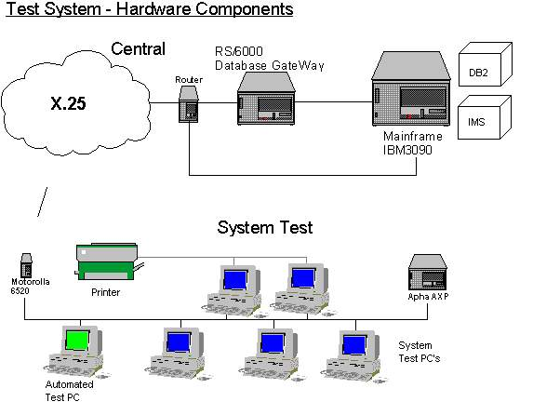

Hardware components required
- 1 Network Controller
- 6 Networked PC's (See below)
- 1 DAP Workstation
- 1 Motorola 6520
- 1 Alpha AXP Server
- 1 Batch Waste Printer
- 1 HP LaserJet 4v Printer
PC Specifications
The 6 PC's required for the test environment will include the following:
1 x P100, 1Gb HD, 16Mb RAM [Current Minimum Specification]
3 x P166, 1.5Gb HD, 32Mb RAM [Current Standard Specification]
1 x P333, 2.5Gb HD, 64Mb RAM [Current Maximum Specification]
These specifications are the various specifications currently in use in different branches.
1 x Pentium running Windows NT is also required as the Test center for controlling and executing the automated testing.

5.3. Software

Test IMS environments
Test IMS region X will be required for System Testing. Additional or amended
data will be populated where required.

Test Environment Software
System Test will be run on the following Software Versions :-
Custom Destop Vers.97.0.1
Windows 95 Operating System
Visual Basic 5 Runtime Files
MS Office 97
Novell Netware

Error Measurement System
This system test will use a bespoke MS Access database Error Management system.
A new database will be implemented for the sole use of this project.
[See Chapter x ]

6. ROLES AND RESPONSIBILITIES

6.1. Management Team
Project Lead – W Mackintosh
Ensure Phase 1 is delivered to schedule, budget & quality
Ensure Exit Criteria are achieved prior to System Test Signoff
Regularly review Testing progress.
Liaise with external Groups e.g. New Systems
Raise and manage issues/risks relating to project or outside Test Teams control.
Review & sign off Test approach, plans and schedule.
Lead Developer – D. Moore
Ensure Phase 1 is delivered to schedule, budget & quality
Regularly review Testing progress
Manage issues/risks relating to System Test Team
Provide resources necessary for completing system test
Report progress at regular status reporting meetings
Resolve user issues

6.2. Testing Team
Testers
Identify Test Data
Execute Test Conditions and Markoff results
Raise Software Error Reports
Administer Error Measurement System
Resolve Design issues
Re-release test software after amendments

6.3. User Group
Review high level / detailed test plans for System Test
Define Procedures
Resolve design issues
Take part in regular Project User Group Team meetings
Execute User Acceptance Testing

